**Week 6 - React**

**1. ReactJS-HOL**

Create a new React Application with the name “myfirstreact”.

**Output**:

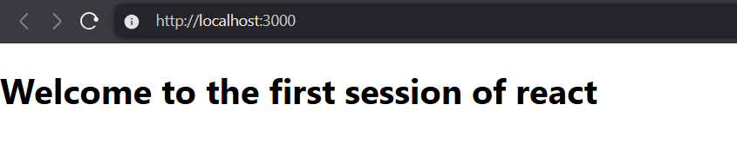

**Code**:

import logo from './logo.svg';

import './App.css';

function App() {

  return (

    <h1>Welcome to the first session of react</h1>

  );

}

export default App;

**2. ReactJS-HOL**

Create a react app for Student Management Portal named StudentApp and create a component named Home which will display the Message “Welcome to the Home page of Student Management Portal”. Create another component named About and display the Message “Welcome to the About page of the Student Management Portal”. Create a third component named Contact and display the Message “Welcome to the Contact page of the Student Management Portal”. Call all the three components.

**Output**:

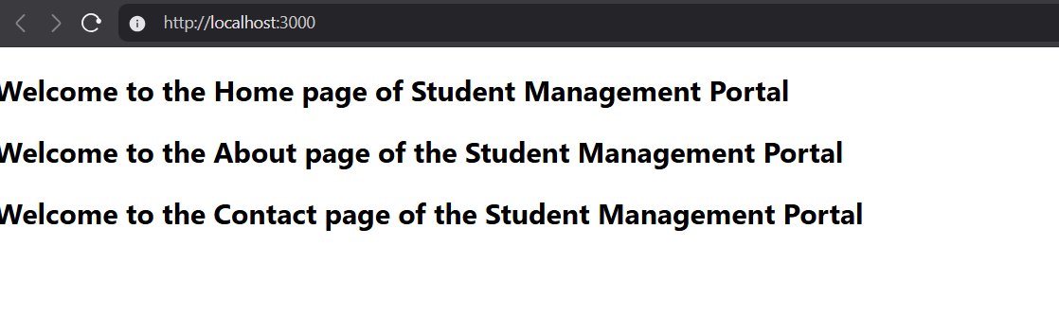

**Code:**

**Src/About.js**

import React from 'react';

function About() {

    return (

        <div>

            <h2>Welcome to the About page of the Student Management Portal</h2>

        </div>

    );

}

export default About;

**Src/App.js**

import React from 'react';

import Home from './Components/Home';

import About from './Components/About';

import Contact from './Components/Contact';

function App() {

  return (

    <div className="App">

      <Home />

      <About />

      <Contact />

    </div>

  );

}

export default App;

**3. ReactJS-HOL**

Create a react app for Student Management Portal named scorecalculatorapp and create a function component named “CalculateScore” which will accept Name, School, Total and goal in order to calculate the average score of a student and display the same.

Output:

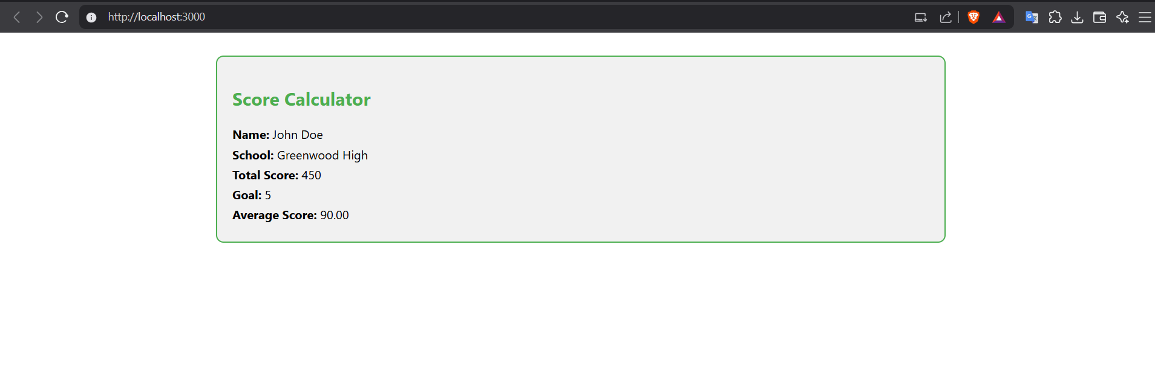

Code:

Src/Components/Calculatorscore:

import React from 'react';

import '../Stylesheets/mystyle.css';

function CalculateScore(props) {

    const average = props.Total / props.Goal;

    return (

        <div className="score-box">

            <h2>Score Calculator</h2>

            <p><strong>Name:</strong> {props.Name}</p>

            <p><strong>School:</strong> {props.School}</p>

            <p><strong>Total Score:</strong> {props.Total}</p>

            <p><strong>Goal:</strong> {props.Goal}</p>

            <p><strong>Average Score:</strong> {average.toFixed(2)}</p>

        </div>

    );

}

export default CalculateScore;

Src/App.js

import React from 'react';

import CalculateScore from './Components/CalculateScore';

function App() {

  return (

    <div className="App">

      <CalculateScore

        Name="John Doe"

        School="Greenwood High"

        Total={450}

        Goal={5}

      />

    </div>

  );

}

export default App;

**4. ReactJS-HOL**

1.Create a new react application using create-react-app tool with the name as “blogapp”

2.Open the application using VS Code

3.Create a new file named as Post.js in src folder with following properties

**Output:**  
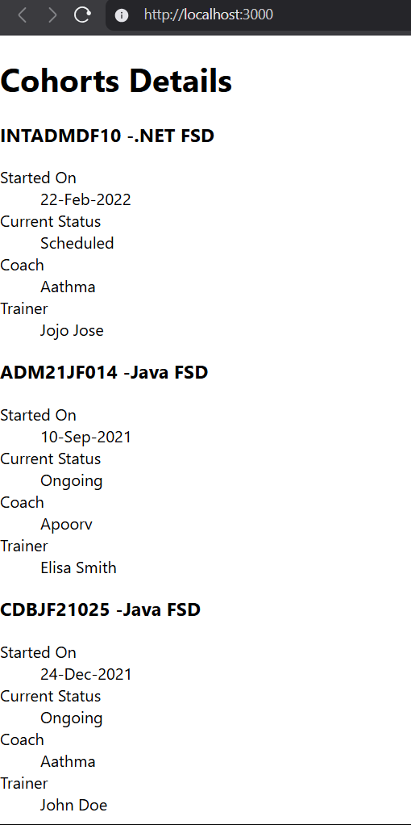

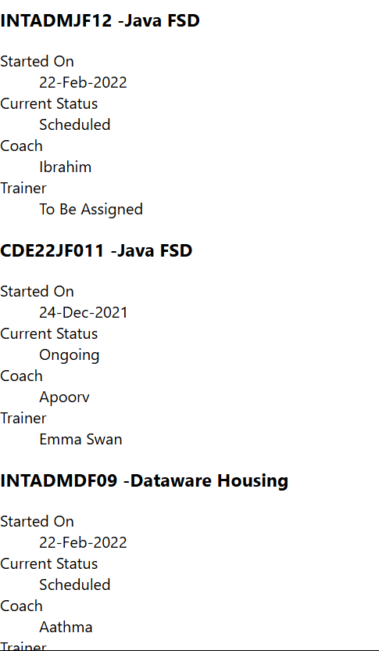

**Code:**

**Src/App.js**

import React from 'react';

import Posts from './Posts';

function App() {

  return (

    <div className="App">

      <Posts />

    </div>

  );

}

export default App;

**5. ReactJS-HOL**

My Academy team at Cognizant want to create a dashboard containing the details of ongoing and completed cohorts. A react application is created which displays the detail of the cohorts using react component. You are assigned the task of styling these react components.

**Output:**

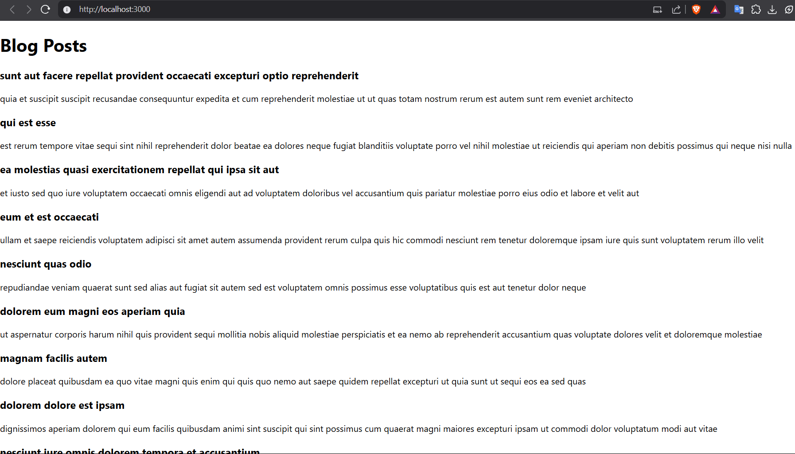

**Code:**

**App.js**

import logo from './logo.svg';

import './App.css';

import { CohortsData} from './Cohort'

import CohortDetails from './CohortDetails';

function App() {

  return (

  <div>

    <h1>Cohorts Details</h1>

    {CohortsData.map(cohort => <CohortDetails cohort={cohort}/>)}

  </div>

  );

}

export default App;

**AppDetails.js**

function CohortDetails(props) {

    return (

        <div>

            <h3>

                {props.cohort.cohortCode} -

                <span>{props.cohort.technology}</span>

            </h3>

            <dl>

                <dt>Started On</dt>

                <dd>{props.cohort.startDate}</dd>

                <dt>Current Status</dt>

                <dd>{props.cohort.currentStatus}</dd>

                <dt>Coach</dt>

                <dd>{props.cohort.coachName}</dd>

                <dt>Trainer</dt>

                <dd>{props.cohort.trainerName}</dd>

            </dl>

        </div>

    );

}

export default CohortDetails;

**Src/setupTests.js**

import '@testing-library/jest-dom';